

[Document title]

[Document subtitle]



[Date]

[Company name]

[Company address]

Q. No1: Write a program in which ask the user to enter the CNIC No and then output if the string is a valid format of Pakistani CNIC or not. Using if else and length() function

Format for CNIC is XXXXX-XXXXXXX-X

Code:

#include <iostream> //Adding io stream

#include <string> //Adding string function for length

using namespace std; //Adding std::

int main() //Calling main function

{ //Starting of code

string cnic; //Making a string variable

cout<<"Input CNIC NUMBER IN FORMAT XXXXX-XXXXXXX-X="; //Displaying CNIC input format

cin>>cnic; //Taking CNIC from user

if ( cnic.length()==15) //Checking of validity of CNIC

cout<<cnic<<"is a valid cnic number."<<endl; //If valid printing out it is calid

else //Otherwise

cout<<cnic<<"is not a valid cnic number."<<endl; //Printing it is not valid

return 0; //Returning value zero after end

} //Ending parenthesis

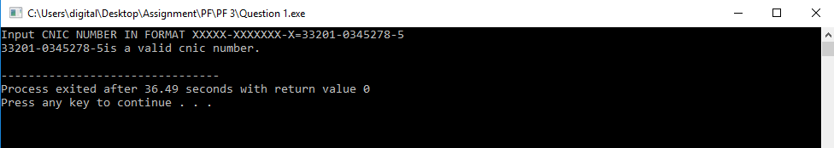

Q. No2: Write a program to check whether the year entered by user is a leap year or not.

e.g. Input year: 2004 2004 is leap year.

Code:

#include <iostream> //Including input output stream

using namespace std; //using namespace std::

int main() //including main function

{ //Starting paranthesis

int year; //Making variable named year

cout<<"Enter the year you want to check="; //Displaying input year

cin>>year; //Taking year number from user

if (year%4==0) // Calculating Year is leap or not

{ //Starting of nested loop

if (year%100==0) // Taking mod by 100

{ //Third nested loop

if (year%400==0) // Taking mod by 400

cout<<year<<" is a leap year."<<endl; //If mod by 400 not zero so its a leap year

else //Other wise condition

cout<<year<<" is not a leap year."<<endl; //Its not a leapyear

} //Closing of third nested loop

cout<<year<<" is a leap year."<<endl; //Mod by 100 not zero than not a leap year

} //Closing of second nested loop

else //Otherwise if mod by 4 not zero

cout<<year<<" is not a leap year."<<endl; //Its not a leap year

return 0; //Returning zero after successful run

} //Ending parenthesis

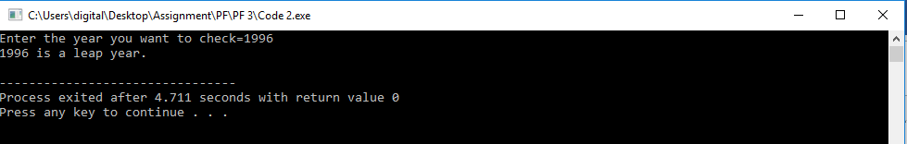

Q. No3: Write a program, in which show a menu of dishes to the user. And ask him to select whatever he wants. After that ask him how much servings he wants to have. Then calculate his total bill and show him on the screen

Code:

#include <iostream> //Calling IO stream

#include <iomanip> //Calling manip library

using namespace std; //using name space std

int main() //Calling main function

{

int biryani=100, jalfrezi=300,icecream=50, servings=0, list=0, bill=0 ; //Declaring variables

int order=0; //Declaring Variable

label: //Goto returning

cout<<"Select dish by its list number 1,2,3="; //Displaying menu

cin>>list; //Getting order from user

if (list==1) //If want Dish1

{

cout<<"Enter how much servings of Biryani=";

cin>>servings;

bill=servings\*biryani;

cout<<"Total bill=:"<<bill<<endl;

}

if (list==2) //If Want dish2

{

cout<<"Enter how much servings of Jalfrezi=";

cin>>servings;

bill=servings\*jalfrezi;

cout<<"Total bill="<<bill<<endl;

}

if (list==3) //If wants dish 3

{

cout<<"Enter how much servings of icecream=";

cin>>servings;

bill=servings\*icecream;

cout<<"Total bill="<<bill<<endl;

}

cout<<"If you want to order again then press 1="; //If you want to order again

cin>>order; //If want to again

if (order==1) //Checking order again or not

goto label; //If yes it goes to taking order again

return 0; //Ending of prog

}

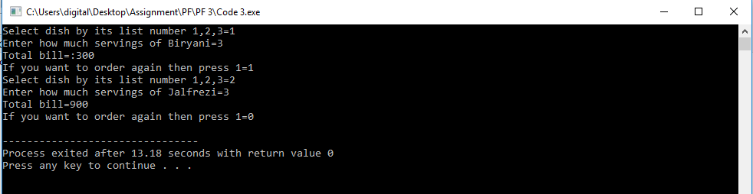

Q. No4: